Heads Up Connect - - - >
Carers’ Group
September 2023 Newsletter
4th September 2023
Dear Everyone,
Yes, its that time again. I’ll try not to write too much in this newsletter. I have a tendency, as you’ve probably gathered, to ramble on until everyone has nodded off!
There is an important note today, so I’m putting it first.
The proposed visit to the Glastonbury Care Home on Friday, 8th September (this coming Friday), has had to be postponed. We are having to look to some time, probably early in the new year, to reschedule. In the next few weeks, we will gather the names of people who are keen to participate in the visit and make arrangements accordingly.
We have received an email from Edwin Jose of Glastonbury Care Home outlining a proposed format for the session which would be a talk about the management of people living with dementia from the Brunel Dementia Care Lead, Stuart Wright. Also, they would be offering on-going support from Gwen Walker who is the resident Wellbeing Coach. When we have more information, we will pass it on to you.
*******************
Friday, 8th September, 10:30 am. The Bishop’s Palace, Wells.
We will still have the gathering in the usual place at the usual time – The Bishop’s Palace Education room, 10:30 am. We can have a good chat, eat cakes, rocky road etc and generally have a good time. If there are any issues that anyone would like to discuss – whether its speakers for next year or something to do with support services, now would be a good time to do it. I was also wondering if, as the weather looks at though its going to be lovely, we might venture into the Bishop’s Palace Gardens using the tickets we were given at the beginning of the year. If anyone didn’t get one, then let me know and I’ll see what I can do.
Message from Jacky Wigley
Jacky has asked me to let you all know that John very sadly passed away peacefully at Fletcher House recently. His funeral is to take place at Mendip Crematorium on Friday, 15th September. I know you will all wish to join me in sending our sincere condolences to Jacky and we will support her as best we can at this very sad time. She is away staying with her family in Switzerland for a few days before the funeral but I’m sure she will appreciate any messages from our group members. I know how valuable it is to have support from others at this difficult time. We send her our very best wishes.
August Heads Up Connect meeting
At the beginning of August, we had an interesting talk from Val and Al who photograph the birds and occasionally other wildlife on the Somerset Levels. They showed us numerous photographs, many of them sunrises and sunsets together with some examples of Starling murmurations , where they have managed to capture the moments when the clouds of starlings somehow seem to form pictures in the sky. They described the ever-changing images of Glastonbury Tor and showed us pictures taken at the Natural England nature reserve at Shapwick Heath and Ham Wall. Some of the videos of the starlings were absolutely stunning and must have taken many hours of patience to capture. Their work is displayed and sold at Somerset Crafts at Westhay. In fact, the whole of the Avalon Marshes craft centre is definitely worth a visit as there a wide range of fascinating arts and crafts by a number of Somerset artists. There’s also a lovely tea-room there where they sell cakes etc.
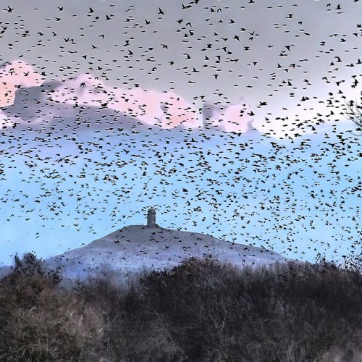
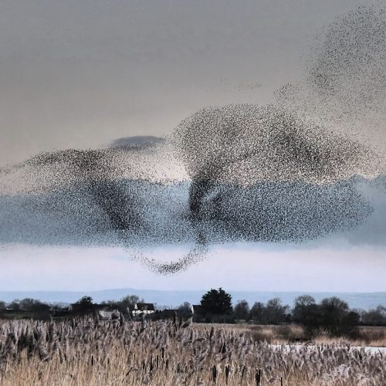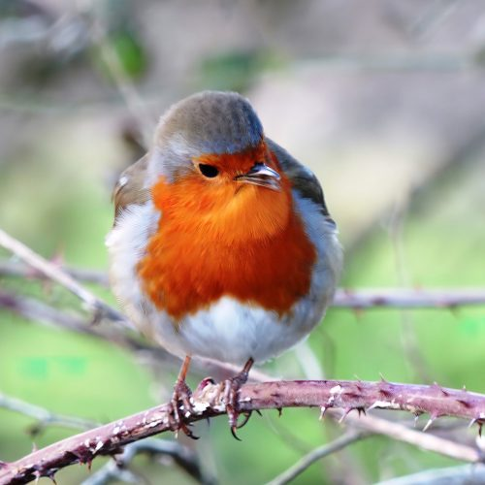
Here are a few examples of Val and Al’s work.
Other meetings this year:
October: Emma McGarva the new Carers Service Coordinator will be coming to let us know what her new role entails and will hopefully be able to give us some clear guidance as to what assistance and support is out there in the County and how we can access it. I think most of us have been in the situation where we haven’t known who or where to turn to in difficult times.
November: Still nothing definite arranged for this month. It would be a good idea to discuss it at Friday’s meeting. I know people enjoyed meeting the Community Police Officer last year. I don’t know if that would be something you might like to have an update on.
Lunch at Wells Golf Club – 22nd September 2023
There was a great turn out again for the August Heads Up Connect lunch at Wells Golf Club. We had ham, egg and chips which was, as always, delicious. Alan was very short staffed that day but still managed to produce 14 meals with his usual efficiency and good humour.
We don’t yet know what is in store for us for the September lunch but, I am sure it will be tasty whatever it is. He is able to cater for vegetarians as well. The 2-course lunch, mains and dessert, is usually around the £8.50 mark, although with ever increasing food prices we can’t say definitely that is what it will be. It is always so good to see everyone chatting and generally having a relaxing time over good food. We usually like to give Alan a bit of notice on numbers, so I’ll see you on Friday to make a list, or failing that, you can email or phone me to let me know if you’d like to join us.
Christmas lunch
As the temperature outside is creeping towards the 30-degree mark, it seems a bit odd to be talking about our Heads Up Connect Christmas lunch! Last year, Alan produced an amazing turkey-with-all-the trimmings-lunch for us. We all had a great time! This year, we will probably do the same again. I seem to remember that, as it’s a much more extensive meal that our usual one, we pay about £17 although again, that might change nearer the time. But it will be a lovely meal – as near a home-cooked meal as you are likely to get when in a restaurant. We have provisionally booked the Golf Club for Friday, 24thNovember.
Book exchange
I noticed that some of our members are exchanging books at the Friday meetings. I think that is a wonderful idea and I think I’ve got a few paperbacks that I could bring along to put on the table at the back of the room, if anyone wants to take them. I also bought a copy of a book I saw reviewed in the paper recently – The Housemates. It is the fascinating account of what happened when a student, Teun Toebes took up residence in a care home. What emerged was his strong views about what is wrong with them and how these misgivings could be addressed. I haven’t finished reading it yet, but when I have, I will bring it along so that someone else can read it if they wish to.
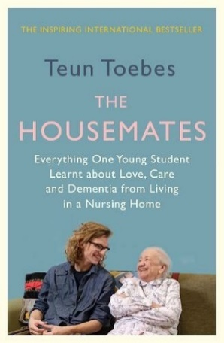
News from Heads Up
Georgina from Heads Up is now producing a newsletter to keep you updated with what is happening there. I’ll try to attach that to the email. I have to say that it looks a lot more professional than mine with a variety of relevant photos! I understand that it is published once every three months and will contain lots of useful and interesting information about what is going on up there.
Cathy and I were amongst a small group of people who went to Heads Up to participate in another creative session with Vanessa Gordon. It was instigated by Jo Sylvester to whose group we occasionally still attend. It was a fun morning and I am hoping the jar I decorated looked a little bit less like it was done by a 5 year old than my previous one. Both Cathy and Vanessa brought along a range of different examples of their work. Cathy has just had a successful stall at Cranmore where she was able to raise enough money to offer a donation to Heads Up which is an extremely generous gesture.
Bridget has asked me to say that they are looking forward to receiving the carers’ feedback forms that were available at the last meeting. They are all part of the continuing quest for information that will support applications for funding for both Heads Up and the carers. I will have a few spares that I can bring with me to the next meeting. If you didn’t get one.
I think that’s all for now. Hope you’re still awake! I look forward to seeing as many of you that can make it on this coming Friday. I will be arming myself with some very sticky ginger cake, rocky road and possibly something else, but not sure yet!
Best Wishes,
Jane

