Heads Up Connect - - - >
Carers’ Group
August 2023 Newsletter
Dear Everyone,
Good afternoon. I hope all is well with you. Having stated blithely in the last newsletter that I was fit and raring to go, I then, almost within hours, came down with Covid. And there was me thinking it was all over bar the shouting. I was not amused. However, it didn’t last long and I hope I’m fine now. My laptop also seems to have recovered from its fit of the vapours and is now cooperating. My holiday seems a long way off now – I hope you’ve all been enjoying this delightfully wet July. Hopefully things will improve this month before Autumn sets in properly (that’s if it hasn’t arrived already).
July meeting – visit from the solicitors, Mogers and Drewett
Normally at this point I would summarise what had happened in the last meeting but as I didn’t attend I haven’t got much idea about what went on. However, I understand that Cara Burr who came to talk to the members was able to shed some interesting light on how vital it is to put in place and maintain an effective Power of Attorney. Inevitably questions also turned to matters of Wills and she was able to offer some interesting advice. The issue was raised of the fine-tuning of the technicalities of home-ownership in the event of the person for whom you are caring passes away. It is important for future planning to ensure that, where you own your own home, the wording on the Land Registry documents is correct. Unfortunately, due to a variety of different reasons, there were not very many members attending this session, but I’m sure that those who were there can provide some idea of what was said.
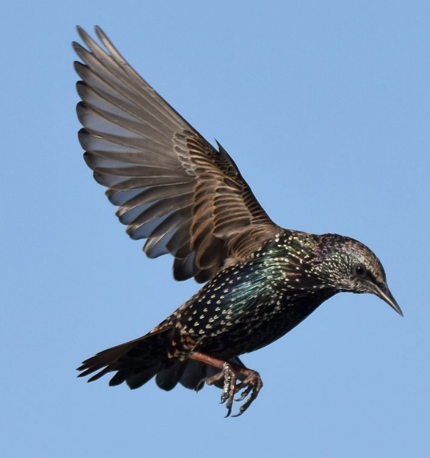
August meeting – an illustrated talk from Val and Al about their photography of birds on the Avalon Marshes.
Education room at Wells Bishop’s Palace. 10:30 – 12:30 (ish) Friday, 11th August
This is the meeting which was postponed from earlier in the year. Val and Al have been photographing the birds, including some fascinating videos of starling murmurations on the Avalon Marshes for a number of years. They will tell us about how this new found career came about and show us some of the beautiful photos they have taken. They are also closely involved with the craft gallery and shop at the Avalon Marshes Centre which has recently been refurbished. It is owned and managed by Natural England. So, we can look forward to a fascinating and hopefully fun talk.
Other meetings this year
September – this is the session where we have been invited by Edwin Jose, manager of the Glastonbury Care Home, to visit this establishment and be welcomed into their training room where we can benefit from advice and information from members of their staff. I am sure there will be a chance to ask any questions you may have. I will consult with you all at the August meeting to ascertain if there are any particular areas you would like covered. We are hoping to secure use of the minibus to transport anyone who needs it. There will also probably be a couple of us driving as well for anyone who would prefer a car ride. I will let you know more when I have found out.
October – visit from Emma McGarva the new Carers Service Coordinator.
November – nothing scheduled at present but we were thinking of asking the Police officer, Sam White to come and speak to us again as many people found his talk useful and informative the last time he came and, I think we have had a few new members since his last visit. There may be other aspects of the service people would like to know about.
December – yet to be decided. Perhaps just having a chat and talking about Christmassy things! Or a workshop to make something Christmassy like table decorations. (Or not!).

Golf Club lunch - 25th August – 12:00 midday. Wells Golf Club
There was an amazing turnout for the July lunch. It was so lovely to see 15 members present and hope that lots of you continue to enjoy this. The meal of chicken and ham pie was delicious. It should be noted that we sang Happy Birthday – twice! The next lunch will be on 25th August in the usual place (Wells Golf Club, South Horrington). If anyone would like a lift, please contact me (07766 054401) and I’m sure we can help. I don’t yet know what the menu will be but I’m sure it will be delicious no matter what. For those of you haven’t been before, it is an informal get together for lunch where we are offered a lovely 2-course lunch where Alan provides a meal of main course and dessert. As he keeps the price down to a phenomenally low price of around £8.50 or £9:00 usually, he manages to do this by offering a single choice (plus veggie option) and ice-cream. It’s always a happy and chatty occasion.
We are aiming to celebrate our Christmas lunch in November. We’re going to be stealing a march on the rest of the world by getting in first before you’re all sick of turkey dinners! So, we are looking at the fourth Friday in November, 24th, when I have no doubt that Alan will produce a lovely meal of turkey and all the trimmings (plus veggie alternative!). The meal will be more extensive than our usual fare and therefore more expensive. I will report back soon and let you know the actual cost. Last year it was around £17 but, of course, with costs going up it might be a little more than that. It was a great celebration last year – just before I swanned off to Australia to spend the festive season boiling in 35°.

As always, if you hear of a person or organisation who you think might be able to offer us an interesting talk at one of our meetings, please feel free to let me know and we’ll see what we can do.
Just for your information I attach some information about a new Carers’ Group which has been set up in Wedmore. It takes place on the first Friday of each month, starting at The Swan Hotel in Wedmore.
When Julie Hanks finished as the contact for Health Connections she was able to pass on a number of information sheets about how to cope with different aspects of caring for someone with Dementia. I’ll bring some with me on Friday so, if you look at the list and think they might be useful, please help yourself, they will each be printed separately. The areas covered are:
Confusion; Anxiety and Agitation; Aggression; Loss of initiative; Hallucinations; Repetition; Sleep disturbance; Sundowning; Suspicion; Time distortion; Top Tips for Carers; Denying dementia: what to do when they will not accept a diagnosis; Pain and Dementia; Wandering.
This information is probably stuff most of us have come across at some time or another but, it never harms to have some reminders.
We now know that Sandra Temple has replaced Julie Hanks at The Mendip Integrated Health and Wellbeing Hub at Vine surgery. We look forward to seeing her sometime at one of our meetings,
Last week I visited the mothership (Heads Up!!) and had the pleasure of meeting Georgina who is the newly appointed Business Support Assistant. She is a lovely person and has a huge job of, amongst other things, organising all the different kinds of volunteers who do a variety of jobs at Heads Up, they all contribute so much to the well being of the clients and their families from helping at the day sessions, driving the minibus and the Outreach helpers who do a tremendous job in keeping carers and their loved ones in touch. Plus all sorts of other things. I hope that she might be able to come to one of our sessions at the Bishop’s Palace one day to meet us all. Looking forward to seeing you on Friday at the Bishop’s Palace.
Best wishes,
Jane xx

