Heads Up Connect 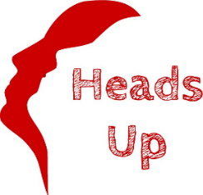
Dates for your diary – 2023
Meeting: Bishop’s Palace, Wells
Second Friday of each month
10:30 am – 12:30 pm

Lunch: Wells Golf Club
South Horrington, Wells
Fourth Friday of each month
12:00 midday

13th January 27th January
10th February 24th February
10th March 24th March
14th April 28th April
12th May 26th May
9th June 23rd June
14th July 28th July
11th August 25th August
8th September 22nd September
13th October 27th October
10th November 24th November
8th December ?

