Heads Up

Memories Newsletter

Issue 2: February – April 2020

“We aspire to improve the lives of those suffering with Dementia and their carers, by enabling choice, control and opportunity in a safe and comfortable environment,”

**WELCOME**

This is the 2nd edition of our quarterly Heads Up Memories Newsletter. If you would like to contribute to future Newsletters, please email Jane [jane@headsupsomerset.org.uk](mailto:jane@headsupsomerset.org.uk) or Mandy [mandy@headsupsomerset.org.uk](mailto:mandy@headsupsomerset.org.uk). Our newsletter aims to give you a snap shot of what’s been happening within our Memories workshops over the previous three months while giving a few hints of up and coming activities to look forward to in the following three months.

**WHATS BEEN HAPPENING**

A VISIT FROM SOCIAL CARE STUDENTS

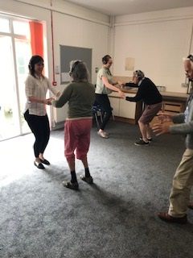During the latter part of 2019 we were fortunate to be joined by some Social Care students on a work experience placement from The Bridge, Wells. They joined in with hosting one of our Silent Disco’s, which as usual proved very popular.

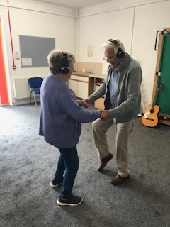

A MUSIC SESSION WITH JANET AND FRIENDS

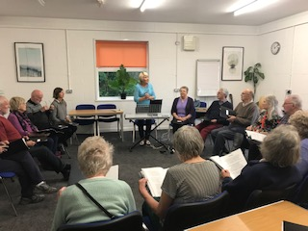One of our popular music sessions with Janet and Friends in December. It has been proven that music evokes emotions that bring back memories even in the most advanced of Alzheimer’s patients. By pairing music with everyday activities, clients can develop a rhythm that helps them to recall the memory of that activity.

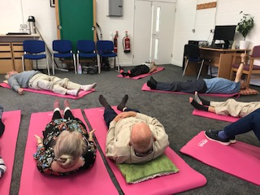TAI CHI WITH CLAIRE WIDDALL

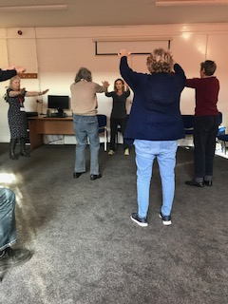A really popular weekly Tai Chi session with Claire Widdall Tai Chi has a wealth of benefits and is particularly enjoyed in our Memories workshops. Tai Chi can improve mood, sleep and cognition in older adults.

MUSIC THERAPY SESSIONS WITH JULIE

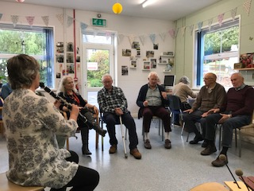Music Therapy sessions take place once a month with Julia. Funded by the Wells Dementia Action Alliance clients have an opportunity to engage and to play the percussion instruments.

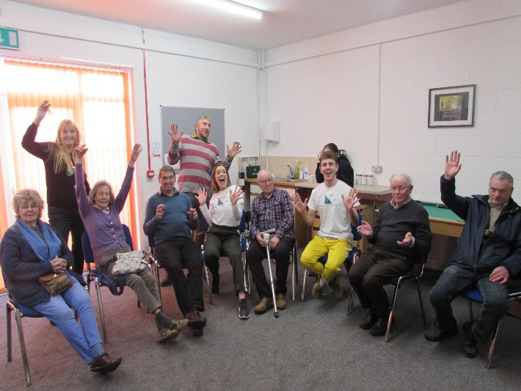AKA DANCE THEATRE

On December 4th 2019 our Memories Workshop were joined by aKa Dance Theatre Company, a small scale company that creates works that are adaptable for a variety of performance surroundings. They have taken their family-friendly work ‘a Real Fiction’ and given it a new twist and more va va voom!

Here’s a quote from aKa Dance Theatre expressing their gratitude to our Memories clients – “Great to work with a group that are so open and eager to try new things. The environment set up at Heads Up

allows the participants to come to a space which is positive, active and stimulating.”

**LOOKING FORWARD**

OUTREACH SUPPORT

Heads Up has recently launched a new Outreach Support Initiative. We support those with Dementia to maintain the skills they still have for as long as possible and enable other clients to learn and develop their life skills in order to live more fulfilling lives. By visiting clients in the community (in their own homes) we are able to provide practical and social support. This can be a one-off visit, providing respite for a particular commitment or it can be more frequent such as weekly or fortnightly. If you would like to find out more about our Outreach Service, please contact Bridget Harvey 01749 670667.

CARERS GROUPS

Come and join us at one of our Carers Groups, a monthly opportunity to meet other people in similar situations, to discuss how things are going and what other services are out there that you may be able to access. From time to time we have guest speakers along to provide advice and information. We meet at the Shepton Brasserie on the second Wednesday of every month 10:30am-12pm and at the Swan Hotel in Wells, on the last Wednesday of every month 10:30am-12pm.

EAST SOMERSET RAILWAY

In November of last year, we were visited by Lisa, a staff member from the East Somerset Railway. The group were able to reminisce about their travels using the old Railway by watching a short film, handling old tickets and listening to a talk. In the Spring we are hoping to organise a joint event where our groups will be able to take a short trip on the Railway, we will let you know more about this once arrangements have been made.