KK
DAY CENTRE
NEWSLETTER

Issue 5:
February – April 2020

Keeping our Friends and Supporters in the picture

FUNDRAISING EVENTS UPDATE
As a charity we are always so grateful when our supporters organise fundraising events for us. Fundraising enables us to continue providing our amazing day centre and outreach work. The following donations & events took place during the months of November, December 2019 & January 2020:
- AMBA WELLS raised £1525.00 from their boutique charity clothes rail.
- WEBB & COMPANY ACCOUNTANTS & FINANCIAL ADVISERS raised £500.00
from their electronic Christmas cards.
- TEPE ORAL HYGIENE raised £500.00
from their electronic Christmas cards.
- DANIELS CAFE raised £46.83 from their book exchange and card sale.
- WELLS VENUE CLUB raised £120.00 from a raffle collection.
- WHITE STUFF FOUNDATION/WELLS STORE raised £146.80 from a variety of fundraising events.
- CLAIRE WIDDALL TAI CHI held a Tai Chi fundraiser and raised £100.00.
- WELLS WALKING GROUP raised £47.00 at their Christmas Lunch collection.

WHAT’S BEEN HAPPENING?
Mendip Hills Winter Conservation
A team of Heads Up conservation volunteers spent a day in December and another in January helping improve habitats for birds and butterflies. Working alongside reserve wardens, the team took part in coppicing at Stock Hill Woods with Forestry England and gorse clearance at Draycott Sleights with the Somerset Wildlife Trust.
Luckily the winter weather was kind and the activities offered a chance to meet new people and visit new places.

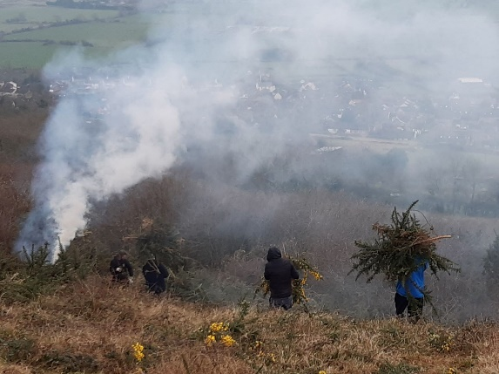
Lantern Making Workshop

In January, Heads Up volunteer, Helene Buttifant, ran a fantastic Lantern Making workshop. Helene said: "I was thrilled to be asked to run a lantern workshop at Heads Up. I worked with a lively group of people. None had ever made a lantern but they all grasped the concept very quickly. We started with a basic triangle shape and added internal structure to strengthen it using willow and masking tape. We covered the lanterns in “wet strength” white tissue paper and left our lanterns to dry before adding our final decorations. At our second session we added coloured tissue over the lantern and made several different designs. The creativity from the group was amazing. We ended up with a colourful bee, a striking cat and a beautiful rainbow. At the end of the second workshop the lanterns were completed. Well done everyone".

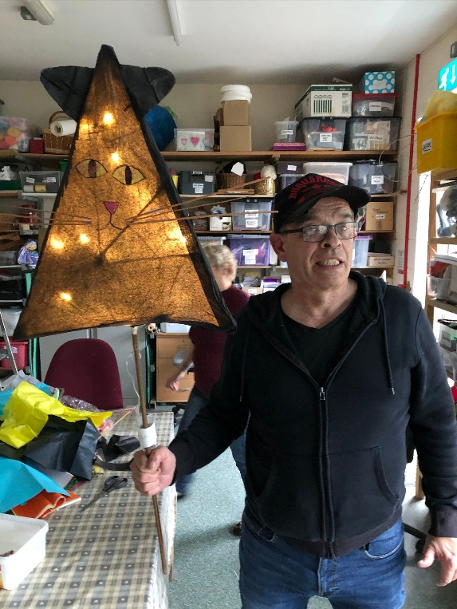

DATES FOR YOUR DIARY

FEBRUARY 2020
Wednesday 19th February, 1pm to 4.30pm, 'Introduction to Mental Health First Aid' Training at Heads Up.
This is an educational course which teaches people how to identify, understand & help a person who may be developing a mental health issue. It teaches you how to recognise those crucial warning signs of mental ill health.
The training costs £65.00 per candidate. To book a place email Vanessa Gordon at: beulahlight@outlook.com, or phone her on 07564071477
Saturday & Sunday 22nd & 23rd, 10am to 4pm: Snowdrop Festival
at The Bishop's Palace, Wells
Heads Up are holding a craft stall on the Sunday, selling craft, woodwork & pottery items made by our clients & volunteers.
Visit @Bishopspalace more information, and visit The Bishops Palace website for pricing details.
Saturday 29th Community Festival of Singing at St Thomas' Church, Wells.
At 2pm you can book to join a fun & inclusive singing workshop, followed by a free concert in the church at 7pm with a retiring collection for Heads Up.
Singing Workshop participation costs £10.00
To book your place email Emma: EWHEATTUITION@GMAIL.COM

MARCH 2020
Sunday 8th Women's Day focusing on Mental Health, 12pm to 4pm in Wells Town Hall
Celebrating National Women's Day, which will include Heads Up giving a 45-minute talk on activity and mental well-being.

