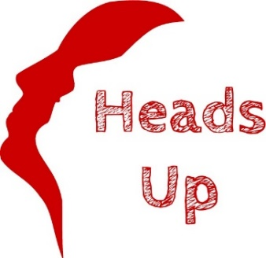

KK
DAY CENTRE
NEWSLETTER

Issue 4:
November - January 2020

Keeping our Friends and Supporters in the picture

FUNDRAISING EVENTS UPDATE:
As a charity we are always so grateful when our supporters organize fundraising events for us. Fundraising enables us to continue providing our amazing day centre and outreach work. The following events took place during the months of August, September & October:
- The Palace Allotment Society celebrated National Allotment Week on 14th & 17th August, and gave tours of their Palace Allotments raising £109.37 for us.
- Peter Williams raised £420.18 for us at his 80th Birthday Party in September.
- Step In Time Line Dancers held a number of line dancing events, raising a total of £1,290.00 for us.
- White Stuff Wells raised another £62.99 for us.
- OTS ran 3 Life Support Training sessions and donated £262.50 to us.
- Mental Health Awareness Trainers Carolyn Smith & Colin Nash ran a Mental Health Master Class and donated £248.76 to us.
OTHER KIND DONATIONS:
We would like to say a massive thank you to:
- Avalon Rotary Club for donating £500.00
- St Cuthbert’s Church for donating £134.90 raised from a Sunday service collection.
- City News, who donate regularly, donated a further £200.00.
- Wells Benevolent Masonic Lodge donated £1,500.00 for our Training Room.
Since April 2019, our Friends & Supporters have helped raise an amazing £19,855.63 for us.
NEW PATRON, TV CELEBRITY DR PHIL HAMMOND, VISITS HEADS UP:
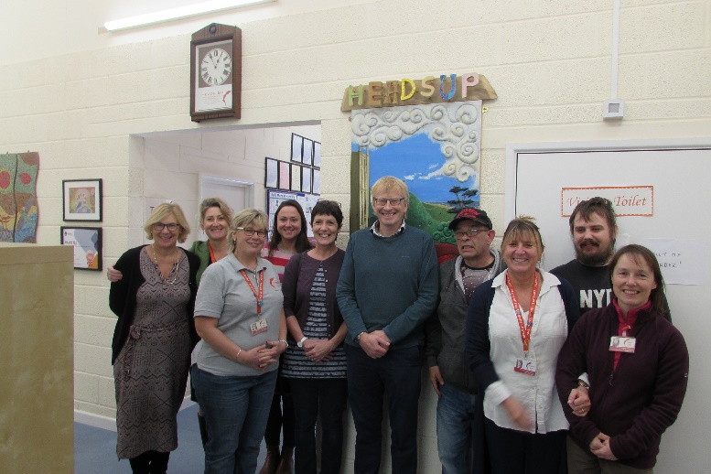
Manager Bridget Harvey showed Dr Phil Hammond and his wife around our day centre, and they had the opportunity to meet & chat with our clients & staff. He was so impressed that he agreed to be our new patron, and he talked passionately about the positive impact that activity has on our mental & physical health.
Dr. Hammond was the Guest Speaker at our fundraising Dinner at The Swan Hotel on Saturday 9th November. His talk was extremely topical, informative, and humorous, with a focus on audience participation.
The event was a fantastic success, with a raffle and live auction, and raised £5,000.00 for our Memories Workshops. We would like to say as massive than you to Dr Hammond for his amazing contribution, Mogers Drewett Solicitors for kindly sponsoring the event, Arnold Wills for taking a lead role in planning & organizing the event and acting as MC, The Swan Hotel for their wonderful generosity in holding the event for us, and Rupert Cox for acting as auctioneer. We would also like to thank the generosity of those would donated raffle and auction prizes, including The Swan Hotel, Burns The Bread, The Bishop's Palace, Royal Bath & West of England Society, Wells Cathedral Visits Department, Goodfellows Restaurant, AMBA Wells/SIX Frome, Pilgrim Financial Planning, Mulberry England, and Wookey Hole Caves.

LLOYDS BANK POTTERY SESSION:Members of staff from Lloyds Bank visited Heads Up on 29th October, to take part in a pottery session run by Sally Dempsey. During the session they made some beautifully designed and intricate hanging decorations. The Lloyds team fed back that they had really enjoyed the experience, and they were very impressed by the facilities and service that we provide for our local community (see photo below).
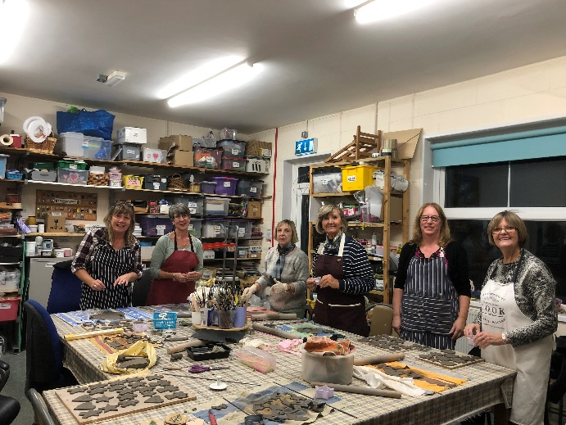
MENTAL HEALTH FIRST AID TRAINING:
In celebration of World Mental Health Day on Thursday 10th October, Trainer Vanessa Gordon and Heads Up ran 3 separate Introduction to Mental Health First Aid Training sessions in the Heads Up Training Room. Mental Health First Aid is an educational course, which teaches people how to identify, understand and help a person who may be developing a mental health issue. In the same way as we learn physical first aid, Mental Health First Aid teaches you how to recognize those crucial warning signs of mental ill health. The feedback we received was very positive:
“Fantastic delivery, we’re lucky to have such a knowledgeable instructor. I’d like to do further training.”
“Very well organized, it makes you appreciate what others may be going through.”
“Very interested in attending further courses. Superb instructor…”
“Very worthwhile training.”
“Lots to think about & ideas to take back to work…”
“Vanessa’s wealth of experience added greatly to the content.”
Vanessa also runs a 2 day Mental Health First Aid course. To find out more or to book a course please contact claire@headsupsomerset.org.uk.

WELLS IN BLOOM WINNER:
Our very own Gardening Tutor, Lee-Anne Bone was one of the judges at this year’s Wells In Bloom competition. Bubwith Almshouses were awarded the Gold Cup in the Communities Award. This award reflects the amazing work that is carried out by the Heads Up gardening group, who help maintain the Bubwith Almshouses gardens. We would like to pass on our congratulations to them.

