NEWSLETTER

KK

Keeping our Friends and Supporters in the picture

Issue 2:
May – July 2019

WELCOME
Welcome to the 2nd edition of our quarterly Heads Up Newsletter. If you would like to contribute to future Newsletters, please email Claire Hak at claire@headsupsomerset.org.uk
FUNDRAISING EVENTS NEWS
Since January our Friends and Supporters have been busy organising fundraising events for us, and so far this year we have raised an incredible £3,886.93 in donations from organised fundraising events!!
An enormous thank you to: Wells Cathedral, volunteer Fiona Golby, The Sun Inn Greek Taverna, Binegar and Gurney Slade Social Group, Enosis Events, White Stuff Foundation and The Venue Club, who have all organised events and collections for us over the past 3 months.
If you would like to organise or support an event, please email Fundraising Officer Claire Hak at claire@headsupsomerset.org.uk

WELCOMING OUR NEW FRIENDS
We would like to welcome the following, who have joined our Annual Friends of Heads Up Scheme:
The New Midrod Ends, Ten Piece Party Band
Christopher Young Opticians

DONATIONS
On 11th March Zac Cambourne from St James’s Place Wealth Management visited with John North, to present a cheque for £2,500.00 to Heads Up, from their Charitable Foundation Fund (see photo below).

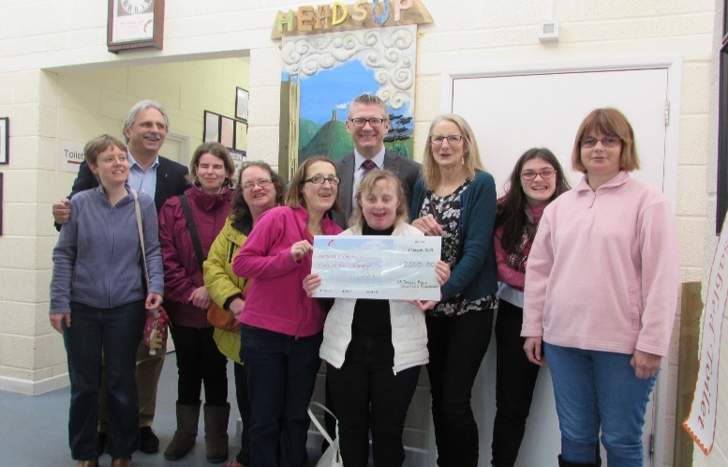

During February, March and April we have also received financial donations from The Masons, Blair Foundation, Redfield Wives Group, St Joseph’s Ladies Group, Mel Kelly, Wells City News, Wells United Church, AA Group and Occupation Training Solutions.
We would like to say a massive thank-you to all of the above for their generous donations.

NATWEST BANK TEAM BUILDING DAY
We would like to thank the Natwest team of volunteers who joined us for the day on 7th March (see photo below). The team very kindly volunteered their time to paint and decorate our kitchen and Memories Workshop, and they did a fantastic job!
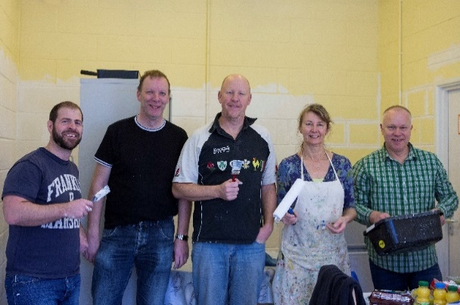

APRIL SOUP! CHARITY EVENT
On Saturday 13th April Heads Up were invited to Wells Connect Centre, along with 3 other charities, to give a short talk about the service we offer. We were then voted in 1st place and awarded an incredible £400.00. A big thank you to Wells Independents for organizing SOUP! every 3 months, and for everyone who voted for us.
OPEN TRAINING DAYS AVAILABLE
Trainers Carolyn Smith & Colin Nash are providing 2 Open Training Days in our Heads Up Training Room:
Mental Health Awareness – June 11th, 9.30 – 4.00 This day looks at common mental health conditions, what support & treatment exists. Demonstrate self-help stress management techniques. Suitable for anyone with an interest in mental health.
Better Mental Health in the Workplace – June 25th, 9.30 – 4.00 This day looks at ways to help employers recognize the issues & how to create ‘mentally healthy workplace.’ Suitable for employers, managers, HR leads & other leaders.

For course cost information and to book a place, please email Claire Hak on claire@headsupsomerset.org.uk
Thank you to all who helped get our Training Room ready, in particular volunteers Andy & Robin Levin, and The Masons who donated an incredible £1,000.00 to purchase chairs.
DEMENTIA ACTION WEEK 20th – 26th MAY
During Dementia Action Week our Wednesday & Friday Memories Workshops will be running a number of additional activities, including Poetry Reading, Yoga and a Ukulele session.
VOLUNTEERS WEEK 3RD - 7TH JUNE
To celebrate our volunteers’ hard work we have organised a Pamper Day at Strode College, where volunteers will be given a choice of beauty treatments or a massage at a reduced price.
EVENTS FOR YOUR DIARY
- Friday 17th May at 7pm & Saturday 18th May at 11am and 7pm:
BEER & CIDER FESTIVAL AT WELLS RUGBY CLUB. Organised by Enosis Events & sponsored by Mallets Cider, raising money for Heads Up. £10.00 per session. For tickets visit www.wellsbeerandciderfestival.com
- Bank holiday Monday 27th May from midday to 4pm:
HORRINGTON FAIR AT HORRINGTON CRICKET CLUB. A fun day for the family organised by Mendip Ladies Group. Heads Up will have a stall, selling a range of items made/grown at our day service.
- Saturday 8th June from 11am to 3pm: PILATES/YOGA MARATHON FUNDRAISER AT PILATES BODY ALIGNED STUDIO, SOUTH HORRINGTON. Raising money in aid of Heads Up. To register to take part, or
to make a donation, please visit www.pilatesbodyaligned.uk or phone 01749 679015.

