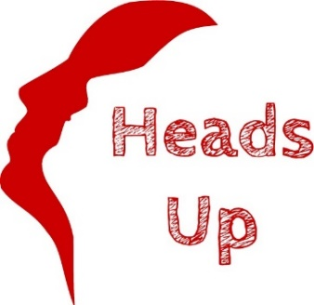

KK
DAY CENTRE
NEWSLETTER

Keeping our Friends and Supporters in the picture
Issue 3:
August - October 2019

WELCOME
Welcome to our quarterly Heads Up Newsletter. Because there is so much happening at Heads Up, we have now decided to produce 2 separate Newletters: one for our Day Centre and one for our Memories Workshop. If you would like to contribute to our Day Centre Newsletter, please email Claire Hak at claire@headsupsomerset.org.uk If you would like to contribute to our Memories Newsletter please email jane@headsupsomerset.org.uk
FUNDRAISING EVENTS NEWS
Our Supporters have been organizing a number of fundraising events for us during the months of May, June & July.
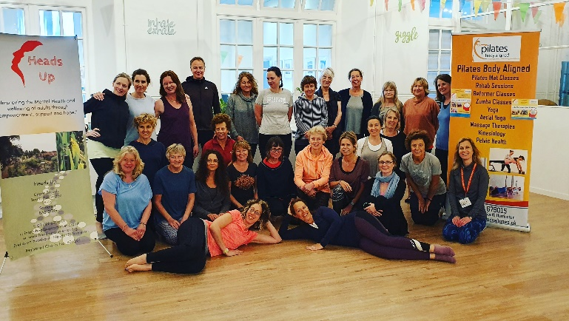
We would like to say a massive thank you to:
Pilates Body Aligned for organizing a Pilates/Yoga Marathon in June, raising an incredible £2,439.71 (photo above)
We would also like to pass on our gratitude to:
Local band The Somerset Russets who held a concert in May raising £392.64
White Stuff Foundation who raised £331.36 from various fundraising events
Trisha Phillips who did a sponsored Head Shave in July and raised £1,141.50
The Inner Wheel of Wells who held monthly raffles and raised £108.00
Wells Venue who ran a Quiz Night in July raising £350.00
Since January, our Friends & Supporters have now raised an amazing £7,491.59 from organizing Fund Raising Events for us.
If you would like to organize or support an event, please email Fundraising Officer Claire Hak at claire@headsupsomerset.org.uk
DONATIONS
During May, June and July we have received financial donations from Daniels Café, Wookey Hub, Keinton Manderville W.I, Mrs Kenney, Mendip District Council, Yeo Valley (Yoekens Scheme), Circle Bath Hospital and Christopher Young Opticians. We would also like to say a special thank you to Mary Snook of Wells, who generously donated one of her Mulberry handbags, which raised £200.00.
WELLS ART CONTEMPORARY 2019
This year the Wells Art Contemporary Exhibition is being held in Wells Cathedral, which is open to the public from 20th July to 11th August.
Heads Up clients, carers, volunteers and staff made a wonderful gargoyle sculpture for the exhibition, called ‘Every Face Tells A Story’ (see photo below, of Sally Dempsey & the sculpture).
This pillar of faces is a fearless expression; a coming together of the Heads Up community. We used inspiration from our visits to Wells Cathedral and expanded on the brief of gargoyles and nature to represent our varied experiences of how creativity can allow us the freedom of expressing ourselves in honest ways.
A pillar of strength, there to comfort those in need of support in difficult times.
This has been a part of our individual journeys, a pillar representing some of our cathartic healing process to holding our heads up high coming out of the darkness into the freedom and empowered headspace of self-acceptance. We found that we could break out from behind our masks of locked in external perceptions of emotional difference, glowing through to proud self-expression. Throughout the creative process we’ve rejoiced in our individuality; we’ve laughed together, we’ve sung together.
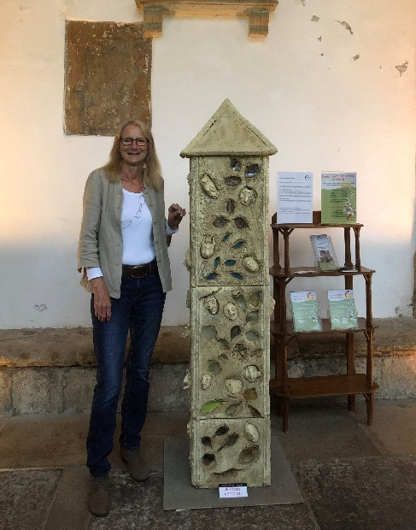
SPECIAL OFFER: MENTAL HEALTH FIRST AID TRAINING ON THURSDAY 10TH OCTOBER
9.30am – 1pm, 1.30pm – 5pm and 6pm – 9.30pm
In celebration of World Mental Health Day, Trainer Vanessa Gordon and Heads Up are running 3 separate Mental Health First Aid Training sessions in the Heads Up Training Room. Each session lasts for 3 hours and is just £65 per candidate (inclusive of light refreshments, registration and accreditation). Mental Health First Aid is an educational course, which teaches people how to identify, understand and help a person who may be developing a mental health issue. In the same way as we learn physical first aid, Mental Health First Aid teaches you how to recognize those crucial warning signs of mental ill health.
To book your place please contact Vanessa Gordon:
Phone 07564071477 or Email beulahlight@outlook.com

EVENTS FOR YOUR DIARY
Wed 14th & Sat 17th August between 12pm & 4pm: Bishops Palace Allotment Open Days
In celebration of National Allotment Week the Bishops Palace Allotment Society are opening their allotments, in the grounds of the Bishops Palace. There will be guided tours, a raffle & much more, raising money for Heads Up.

Bank Holiday Monday 26th August: Wells Moat Race Organized by Lions Club. Heads Up will be holding a Craft Stall selling arts & crafts, woodcrafts, garden and pottery items made by our clients and volunteers.

Thursday 10th October 7.30pm: Open Mic Night
Wells Venue are celebrating World Mental Health Day by holding an evening of local musical artists, raising money for Heads Up. Free entry, donations welcome.

